January 9, 2022

Angiosperms – Flowering Plants

The term angiosperm is derived from the Greek words ('container, vessel') and ('seed'). This refers to plants that produce their seeds enclosed within a fruit. Angiosperms are the most recognized groups of plants due to production of flowers. Their reproduction structures are in the flowers. The ovules are enclosed in the ovary. Figure 1 shows the diagram of the flower’s anatomy.

Angiosperms have been the dominate vegetation on land for over 60 million years. It is estimated that there are over 369,000 species of flowering plants. This is more than all other land plants combined. have 64 orders, 416 families, approximately 13,000 known genera and 300,000 known species.

Angiosperms include a variety of species including trees, herbs, submerged aquatics, bulbs, and epiphytes. Angiosperms are found in almost every habitat.

There are eight groups of living angiosperms - Amborellales, Nymphaeales, Austrobaileyales, Chloranthales, Magnoliids, Monocots, Ceratophyllum, Eudicots.

The basal angiosperms are the earliest diverging lineages of flowering plants. The most well-known species are laurels, magnolias, and waterlilies.

Figure 1

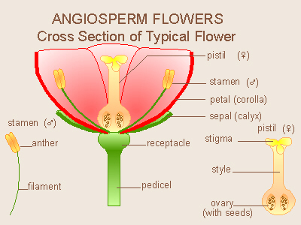

Image source - <https://biologyclermont.info/wwwroot/courses/lab2/angiosperms%20intro.htm>

References

Byng, J.W. 2014. The Flowering Plants Handbook: A Practical Guide to Families and Genera of the World. Plant Gateway Ltd. Hertford, U. K.

Global Biodiversity Information Facility. 09 Jan 2022. Angiosperms. Global Biodiversity Information Facility. <https://www.gbif.org/species/113551078#:~:text=Like%20gymnosperms%2C%20angiosperms%20are%20seed,fruits%20that%20contain%20the%20seeds>.

Kenrick, P. 2005. Angiosperms. Science Direct. <https://www.sciencedirect.com/science/article/pii/B9780081029084002022>.

The Plant List.2010. The Angiosperms (Flowering plants). The Plant List. <http://www.theplantlist.org/browse/A/>.

Stein Carter, J. 12 Sep 2019. Angiosperms: Flowering Plants. biologyclermont.info. <https://biologyclermont.info/wwwroot/courses/lab2/angiosperms%20intro.htm>.